

**US Army Corps of Engineers**

**Afghanistan Engineer District**

AED Design Requirements:

Vertical Curve Design

Various Locations, Afghanistan

MARCH 2009

**TABLE OF CONTENTS**

AED DESIGN REQUIREMENTS FOR

VERTICAL CURVE DESIGN VARIOUS LOCATIONS, AFGHANISTAN

Section Page

**1. General 1**

**2. Vertical Curves 1**

**3. Crest Vertical Curve Stopping Sight Distance 1**

**4. Crest Vertical Curve Passing Sight Distance 3**

**5. Sag Vertical Curves 5**

**6. Design Considerations 7**

**7. As-Builts 7**

Exhibits

Exhibit 1. Types of Vertical Curves 1

Tables

Table 1. Stopping Sight Distance 1

Table 2. Design Control for Stopping Sight Distance and for Crest Vertical Curves 2

Table 3. Passing Sight Distance for Design of Two-Lane Highways 3

Table 4. Design Controls for Crest Vertical Curves Based on Passing Sight 4

Distance

Table 5. Design Control for Sag Vertical Curves 6

**1. General**

The purpose of this document is to provide requirements to Contractors for any project requiring the design and construction of vertical curve road design.

**2. Vertical Curves**

Vertical curves are parabolic curves used to achieve a gradual change between tangent grades (G1 and

G2) and may be either a crest curve or a sag curve as shown in Exhibit 1.

Exhibit 1. Types of Vertical Curves

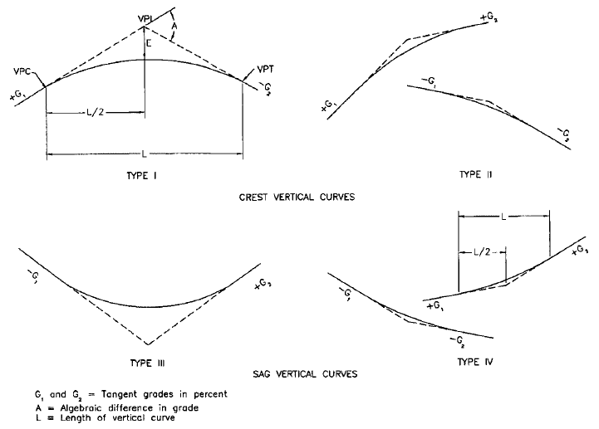

**3. Crest Vertical Curves Stopping Sight Distance**

The major control for safe operation on a crest vertical curve is the sight distance required. At the minimum, the stopping sight distance for the road design speed provided in Table 1 should be provided for all crest vertical curves. Wherever practical, larger stopping sight distances should be used.

Table 1. Stopping Sight Distance

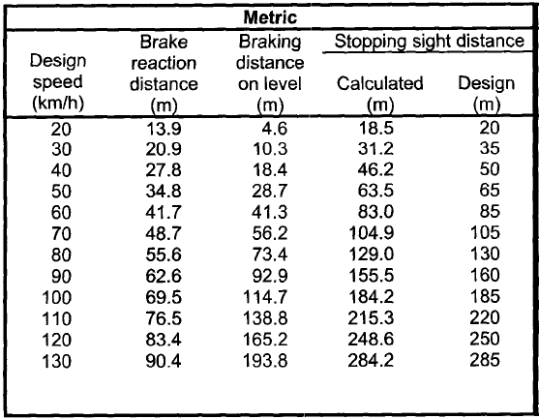

Equations 3-1 and 3-2 provide the general equations for calculating the minimum length of crest vertical curves based on the required sight distance and the algebraic difference in grade. Equation 3-1 is to be used if the required sight distance is less than the length of the vertical curve and Equation 3-2 is to be used if the required sight distance is greater than the length of the vertical curve.

Equation 1 L=(AS)2/100((2h1)1/2+(2h2)1/2)2 (S<L)

1/2

1/2 2

Equation 2 L=2S-(200(h1

+h2

) )/A) (S>L)

Where:

L=length of vertical curve (m) S=sight distance (m)

A=algebraic difference in grades (%) h1=height of eye above roadway surface (m) h2=height of object above roadway surface (m)

When the height of the eye and the height of the object are 1.08 meters and 0.6 meters respectively, as used for stopping sight distance, general equation 3-1 and 3-2 become the requires crest curve length for stopping sight as shown in equations 3-3 and 3-4 respectively.

Equation 3 L=AS2/658 (S<L) Equation 4 L=2S-(658/A) (S>L)

Where:

L=length of vertical curve (m) S=sight distance (m)

A=algebraic difference in grades (%)

The rate of vertical curvature (K) is equal to the length of the vertical curve (L) divided by the algebraic difference in the tangent grades (A) in percent (K=L/A). For a given design speed the minimum length of the crest vertical curve for stopping sight distance can be verified by determining the rate of vertical curvature and checking this value against the rate of vertical curvature provided in Table 2 for the design speed of the road. An alternative method to determining the minimum length of a crest vertical curve (L) for stopping sight distance is to multiply the rate of vertical curvature (K) for the design speed of the roadway by the algebraic difference in the tangent grades (A) in percent (L=K*A).

Table 2. Design Controls for Stopping Sight Distance and for Crest Vertical Curves

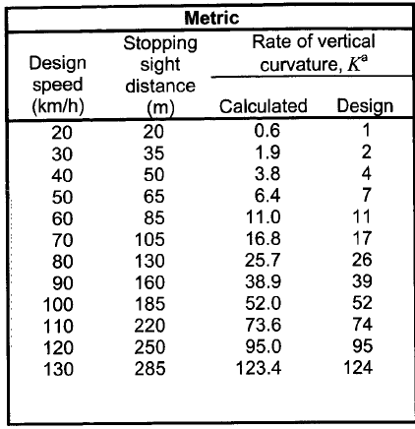

***Example 1: With a two-lane crest vertical curve with entering and exiting tangent grades of***

***+2.00% and -3.75% respectively and a design speed of 100 km/h, calculate the minimum vertical curve length for stopping sight distance.***

*From Table 2 with a 100 km/h design speed, the required stopping sight distance is 185 meters and the rate of vertical curvature is 52. Using Equation 3-3 the length of the vertical curve can be determined.*

*L=AS2/658=[(2.00+3.75)*1852]/658=299.08 meters.*

*Since the sight distance (185 meters) is less that the length of the vertical curve (299.08 meters) we can verify that the rate of vertical curvature meets the design requirements.*

*K=L/A=299.08/(2.00+3.75)=52.01 > 52*

*The rate of vertical curvature for the 299.08 meter long vertical curve meets or exceeds the required rate of vertical curvature from Table 2 the curve length is satisfactory.*

***Example 2: With a two-lane crest vertical curve with entering and exiting tangent grades of***

***+8.00% and +4.15% respectively and a design speed of 80 km/h, calculate the minimum vertical curve length.***

*From Table 2 with an 80 km/h design speed, the required stopping sight distance is 130 meters and the rate of vertical curvature is 26. Using Equation 3 the length of the vertical curve can be determined.*

*L=AS2/658=[(8.00-4.15)*1302]/658=98.88 meters.*

*Since the sight distance (130 meters) is larger that the length of the vertical curve (98.88 meters)*

*calculated with Equation 3 the required length of the vertical curve is calculated with Equation 4. L=2S-(658/A)=2*130-(658/(8.00-4.15)=89.09 meters.*

*With the calculated sight distance known, we can verify that the rate of vertical curvature meets the design requirements.*

*K=L/A=89.09/(8.00-4.15)=23.14 < 26*

*Since the rate of vertical curvature for the 89.09 meter long vertical curve does not meets the required rate of vertical curvature from Table 2 the vertical curve length is determined by the rate of vertical curvature.*

*L=KA=26*(8.00-4.15)=100.10 meters.*

*The minimum vertical curve length should be 100.10 meters.*

**4. Crest Vertical Curve Passing Sight Distance**

Design values of crest vertical curves for passing sight distance differ from those for crest stopping sight distance because of the different sight distance and object height criteria. The required passing sight distance for various design speeds can be obtained from Table 3 shown below.

Table 3. Passing Sight Distance for Design of Two-Land Highways

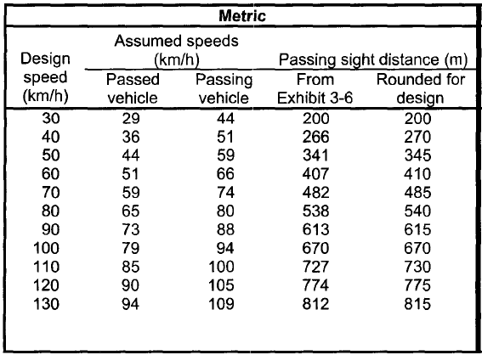

The height of the object for passing sight distance increases to 1.08 meters from 0.60 meters for stopping sight distance. These two factors result in crest passing sight distances that are substantially longer than the crest stopping sight distance. When the height of the eye and the height of the object are both 1.08 meters, as used for padding sight distance, Equation 1 and Equation 2 become the requires crest curve length for passing sight as shown in Equation 5 and Equation 6 respectively.

Equation 5 L=AS2/864 (S<L) Equation 6 L=2S-(864/A) (S>L)

Where:

L=length of vertical curve (m) S=sight distance (m)

A=algebraic difference in grades (%)

Again, the rate of vertical curvature (K) is equal to the length of the vertical curve (L) divided by the algebraic difference in the tangent grades (A) in percent (K=L/A). For a given design speed the minimum length of the crest vertical curve for passing sight distance can be verified by determining the rate of vertical curvature and checking this value against the rate of vertical curvature provided in Table 4 for the design speed of the road. An alternative method to determining the minimum length of a crest vertical curve (L) for passing sight distance is to multiply the rate of vertical curvature (K) for the design speed of the roadway by the algebraic difference in the tangent grades (A) in percent (L=K*A).

Table 4. Design Controls for Crest Vertical Curves Based on Passing Sight Distance

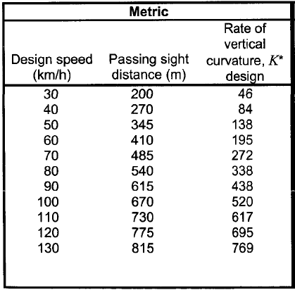

***Example 3: With a two-lane crest vertical curve with entering and exiting tangent grades of***

***+2.00% and -3.75% respectively and a design speed of 100 km/h, calculate the minimum vertical curve length for stopping sight distance.***

*From Table 4 with a 100 km/h design speed, the required passing sight distance is 670 meters and the rate of vertical curvature is 520. Using Equation 5 the length of the vertical curve can be determined.*

*L=AS2/864=[(2.00+3.75)*6702]/864=2987.47 meters.*

*Since the sight distance (670 meters) is less that the length of the vertical curve (2987.47 meters) we can verify that the rate of vertical curvature meets the design requirements.*

*K=L/A=2987.47/(2.00+3.75)=519.56 < 520*

*Since the rate of vertical curvature for the 2987.47 meter long vertical curve does not meets the required rate of vertical curvature from Table 4 the vertical curve length is determined by the rate of vertical curvature.*

*L=KA=520*(2.00+3.75)=2990.00 meters.*

*The minimum vertical curve length should be 2990.00 meters.*

**5. Sag Vertical Curves**

At least four different criteria for establishing the length of sag vertical curves are recognized to some extent. These are headlight sight distance, passenger comfort, drainage control, and general appearance. Of these four criteria, the headlight sight distance is the basis for determining the length of sag vertical curves. Equation 7 and Equation 8 show the general equations for sag vertical curve stopping sight distance based on an eye and object heights of 1.08 meters and 0.6 meters respectively.

Equation 7 L=AS2/[200(h1+S(tan z))] (S<L) Equation 8 L=2S-[(200(h1+S(tan z)))/A] (S>L)

Where:

L=length of vertical curve (m) S=sight distance (m)

A=algebraic difference in grades (%)

h1=height of headlight (m)

z=upward divergence of headlight beam (o)

A headlight height of 0.60 meters and a 1-degree upward divergence of the light beam from the longitudinal axis of the vehicle are commonly assumed. Equations 7 and 8 become Equations 9 and 10 respectively, with the known relationship between the length of the sag vertical curve (L) in meters, the algebraic difference in grades (A) in percent and the distance between the vehicle and point where the 1- degree upward angle of the light beam intersects the surface of the roadway (s) in meters.

Equation 9 L=AS2/(120+3.5S) (S<L) Equation 10 L=2S-[(120+3.5S)/A] (S>L)

Where:

L=length of vertical curve (m) S=sight distance (m)

A=algebraic difference in grades (%)

For overall safety, a sag vertical curve should be long enough that the light beam distance in nearly the same as the stopping sight distance. Accordingly, it is appropriate to use the stopping sight distances for different design speeds as the value of S in the above equations. As in the case of crest vertical curves,

it is convenient to express the design control in terms of the rate of vertical curvature (K). Again the rate of vertical curvature is equal to the length of the vertical curve (L) divided by the algebraic difference in the tangent grades (A) in percent (K=L/A). For a given design speed the minimum length of the sag vertical curve can be verified by determining the rate of vertical curvature and checking this value against the rate of vertical curvature provided in Table 5 for the design speed of the road. An alternative method to determining the minimum length of a sag vertical curve (L) is to multiply the rate of vertical curvature (K) for the design speed of the roadway by the algebraic difference in the tangent grades (A) in percent (L=K*A).

Table 5. Design Control for Sag Vertical Curves

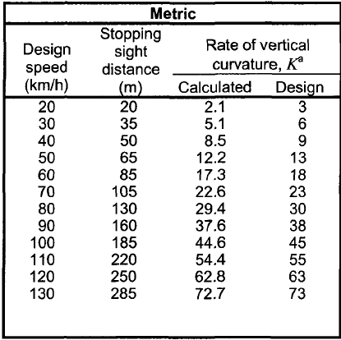

***Example 4: With a two-lane sag vertical curve with entering and exiting tangent grades of -2.50% and +4.00% respectively and a design speed of 100 km/h, calculate the minimum vertical curve length.***

*From Table 5 with a 100 km/h design speed, the required stopping sight distance is 185 meters and the rate of vertical curvature is 45. Using Equation 9 the length of the vertical curve can be determined.*

*L=AS2/(120+3.5S)=[(2.50+4.00)*1852]/(120+(3.5*185)=289.85 meters.*

*Since the sight distance (185 meters) is less that the length of the vertical curve (289.85 meters) we can verify that the rate of vertical curvature meets the design requirements.*

*K=L/A=289.85/(2.50+4.00)=44.59 < 52*

*Since the rate of vertical curvature for the 289.85 meter long vertical curve does not meets the required rate of vertical curvature from Table 5 the vertical curve length is determined by the rate of vertical curvature.*

*L=KA=45*(2.50+4.00)=292.50 meters.*

*The minimum vertical curve length should be 292.50 meters.*

***Example 5: With a two-lane sag vertical curve with entering and exiting tangent grades of -8.00% and -5.30% respectively and a design speed of 80 km/h, calculate the minimum vertical curve length.***

*From Table 5 with an 80 km/h design speed, the required stopping sight distance is 130 meters and the rate of vertical curvature is 30. Using Equation 9 the length of the vertical curve can be determined.*

*L=AS2/(120+(3.5S)=[(8.00-5.30))*1302]/(120+(3.5*130)=79.36.*

*Since the sight distance (130 meters) is larger that the length of the vertical curve (79.36 meters)*

*calculated with Equation 9 the required length of the vertical curve is calculated with Equation 3-10. L=2S-[(120+(3.5S))/A]=2*130-[(120+(3.5*130))/(8.00-5.30)]=47.03 meters.*

*With the calculated sight distance known, we can verify that the rate of vertical curvature meets the design requirements.*

*K=L/A=47.03/(8.00-5.30))=17.42 < 30*

*Since the rate of vertical curvature for the 47.03 meter long vertical curve does not meets the required rate of vertical curvature from Table 5 the vertical curve length is determined by the rate of vertical curvature.*

*L=KA=30*(8.00-5.30)=81.00 meters.*

*The minimum vertical curve length should be 81.00 meters.*

**6. Design Considerations**

The following design considerations, in addition to the criteria listed above, should be reviewed for all horizontal curves to endure a safe design.

The “roller-coaster” type of profile should be avoided. Such profiles generally occur on relatively straight horizontal alignments where the roadway profile closely follows a rolling natural ground line. This type of profile is avoided by the use of horizontal curves or by more gradual grades.

A “broken-back” gradeline (two vertical curves in the same direction separated by a short tangent section) should be avoided, particularly in sags. “Broken-back” gradelines can be avoided by changing the grade lines or the lengths of the vertical curves.

Sag vertical curves should be avoided in cut sections unless adequate drainage can be provided.

**7. As-Builts**

Upon completion of construction of the roadway, The Contractor shall submit editable CAD format As- Built drawings. The drawing shall show the final product as it was installed in the field, with the exact dimensions, locations, materials used and any other changes made to the original drawings. Refer to Contract Sections 01335 and 01780A of the specific project for additional details.